Analysis of Hydrates
Objectives:
To calculate the percent water by mass in several hydrated compounds; to dehydrate an unknown solid sample and identify it by comparing its percent water with known hydrated compounds
Materials:
Hydrated salts (BaCl₂2H₂O, CaSO₄2H₂O, CuSO₄5H₂O, NiCl₂6H₂O, MgSO₄7H₂O).
Note: The magnesium sulfate crystals should be clear and transparent; the presence of white crystals indicates a mixture of 6-hydrate and lower.
Safety:
Handle hot glassware carefully – objects remain hot long after heating is discontinued. Solid samples may tend to spatter during heating. Wear safety goggles at all times in the laboratory.
Waste Disposal:
All solids may be dissolved in water and rinsed down the sink with plenty of water.
INTRODUCTION
Many solids, especially inorganic salts, occur naturally as hydrates. This means that water molecules are incorporated into the crystal lattice of the compound in such a way that the water is chemically bound. Some of these materials may spontaneously lose water molecules when placed in contact with dry air, a process known as efflorescence. Other hydrates are hygroscopic, meaning that they absorb water from humid air. These materials are often used as desiccants, or drying agents. For example, many electronic products are shipped with small packets of silica which acts as a desiccant to protect the electronics from the effects of humidity. Some solids absorb so much humidity from the air that they then start to dissolve in the large quantity of absorbed water, a process known as deliquescence.
Some hydrates exist in equilibrium with moisture in the air, absorbing or releasing water molecules depending on the relative humidity. One example is cobalt (II) chloride, which absorbs or releases water n a reversible process:
CoCl₂ 6H₂O_{(s)} CoCl_{2 (s)} + 6H₂O_{(l)}
(pink) (blue)

Cobalt chloride is used in many novelty items, such as weather strips to predict the weather. When the chance of rain increases and the relative humidity is high, the cobalt chloride absorbs water to form the hydrated salt and the weather strip turns pink. when the relative humidity drops during fair weather the compound releases water and reverts to the anhydrous form, and the weather strip turns blue.
Hydrated salts are not simple solids that are wet or that have moisture adsorbed on their surface. They are compounds in which water molecules are incorporated into the crystal structure of the salt, chemically combined with the cations and anions. The is reflected in the chemical formula of the salt, which includes the specific number of water molecules in the unit cell (or moles of water per mole of salt). Thus, the hydrated cobalt chloride (CoCl₂ 6H₂O) includes six water molecules in its unit cell, or six moles of water per one mole of salt. The common notation for hydrated salts is to use a raised dot () between the formula for the salt and the number of water molecules n the compound. Alternatively, the formula for hydrated salts can be written with the water molecules n parentheses, with the number of water molecules indicated using a subscript. In other words:
CoCl₂ 6H₂O = CoCl₂(H₂O)₆
Because water is part of the chemical structure of a hydrated salt it is important to specify the amount of water when naming hydrates. The rule for naming hydrated salts is to start with the name of the salt, and add the term “hydrate” with a Greek numerical prefix to indicate the molar ratio of water in the compound. These prefixes are listed in Table One below.
Thus: CuSO₄5H2O would be called “copper (II) sulfate pentahydrate”, and BaCl₂2H₂O would be called “barium chloride dihydrate”.
Table One. Greek prefixes for numbers
# of water molecules | Greek prefix
1 | mono
2 | di
3 | tri
4 | tetra
5 | penta
6 | hexa
7 | hepta
8 | octa
9 | nona
10 | deca

In this laboratory you will identify an unknown hydrated salt from a list of potential unknowns. Water of hydration is easily removed from the compound by heating it to above 100ºC (the boiling point of water). By measuring the mass of water lost upon heating from a given amount of hydrated salt, the percent water by mass can be calculated and compared to the theoretical values based on the formulas of known compounds.

Name_____________________________________ Date__________________________________

Pre-Lab Questions

- Define the following terms:
  - Hydrate
  - Desiccant
  - Anhydrous
  - Efflorescence
  - Deliquescence
  - Absorb vs. Adsorb (what is the difference?)

- Name these compounds
  - Ba(OH)₂8H₂O
  - Cu(NO₃)₂3H₂O
- A sample of a hydrated salt weighing 1.048 g is heated until no more water is given off and a relatively constant weight is obtained. The mass of the anhydrous salt was 0.893 g. What is the mass of water lost by the sample? Calculate the mass percent of water in the hydrated salt.
- Calculate the mass percent of water in Na₂CO₃10H₂O. Report your answer to 4 significant figures.
- Two hydrates commonly called “gypsum” and “Epsom salts” have many uses. Identify these compounds and some of the applications in which they are used.

Name_____________________________________ Date__________________________________
Procedure
Observe all safety precautions when working with reagents and performing reactions.
- Weigh a clean and dry 100 or 150 mL beaker and a piece of metal foil together on a top loading balance. Record this mass on your Data Sheet.
- Without using the tare button and while the beaker is still on the balance, place about 2-3 grams of the unknown hydrate crystals into the beaker. Record the unknow ID code on your Data Sheet. Record this mass on your Data Sheet.
- The mass of the unknown sample can be determined by difference.
Figure One
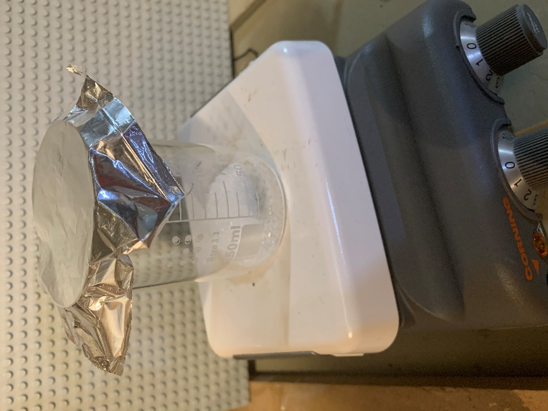
- Heat the contents of the beaker without the metal foil for about 15 minutes at about 120ºC (Figure One)
- Cover the beaker with the metal foil then place the beaker on a wire gauge. Allow it to cool for 10 minutes then weigh the covered beaker on the same balance you used before. Record the mass on your Data Sheet.
- Return the beaker to the hot plate and repeat steps 4 and 5. If the weight after the second heating agrees with the mass after the first heating (within 0.005 g) then no further heating is necessary. If the second heating appeared to drive off additional water, then heat a third time, cool and re-weigh. Continue until you obtain agreement between successive weighings.
- Record any observations regarding the appearance of the anhydrous salt.
- Repeat steps 2-6 using a second sample of the same unknown. Calculate the percent water by mass in each sample. Average your values for the two trials.
- Add a few drops of water to your anhydrous salt. Record any changes in the appearance of the salt on your Data Sheet. Dissolve any remaining solid and rinse down the sink with plenty of water. Clean the glassware you used.

Calculations
- Calculate the mass of each hydrated salt sample by difference.
- Calculate the mass of water lost as the difference between the mass of the hydrated salt and the mass of the anhydrous salt.
- Calculate the percentage of water by mass in each sample:
% water = (weight of water lost$÷$weight of hydrated salt) X 100
Record all calculation results on your Data Sheet.
- Calculate the theoretical percentage of water by mass for each of the possible unknowns listed on your Data Sheet.
- Identify your unknow hydrated salt by comparing the average percentage of water by mass for your unknown with the calculated theoretical percentage of water for the salts listed on your Data Sheet.

Name_____________________________________ Date__________________________________

Water of Hydration Data Sheet

Unknown Code___________________________

All mass measurements are in grams | Trial One | Trial Two
Mass of beaker + foil
Mass of beaker, foil + hydrated salt
Mass of beaker, foil + anhydrous salt (1)
Mass of beaker, foil + anhydrous salt (2)
Mass of beaker, foil + anhydrous salt (3)

CALCULATIONS
All mass calculations are in grams | Trial One | Trial Two
Mass of hydrated salt
Mass of anhydrous salt
Mass of H₂O lost
Percent water in Unknown
Average % water
Identity
Actual Identity
% Error | [(ave. value – theo. value)$÷$theo. value] *100%

CALCULATIONS OF PERCENTAGE WATER FOR POSSIBLE UNKNOWNS
Show work on calculations

BaCl₂2H₂O

ZnSO₄7H₂O

CuSO₄5H₂O

NiCl₂6H₂O

MgSO₄7H₂O

SrCl₂6H₂O

Name_____________________________________ Date__________________________________
Post-Lab Questions
- Discuss possible sources of error, paying attention to the direction (high or low) of the error.
- Write the formula for your unknown and give its correct chemical name.
- Did the appearance of your unknown change when it was dehydrated and rehydrated? Why do you think this is so?
- Heating some hydrates too strongly may cause them to decompose. For example, some sulfates can emit SO₂ and some carbonates can emit CO₂ upon strong heating. If this were to occur in this experiment would the calculated mass percentage of water be too low or too high? Explain your answer.
- A student takes 1.658 g of hydrated iron (III) nitrate and heats it in a crucible. The anhydrous material weighed 0.991 g. What is the formula and name for this hydrated salt? Show your work.

